# **From the Director**

# Dear Friends and Supporters,

# I hope this letter finds you well and enjoying the summer season. As the Director of Options for Independent Living, I am excited to share with you the incredible happenings we've had over the past few months. It has been a truly remarkable and busy summer here at Options, filled with celebrations, advocacy, and community engagement.

# Our summer began with a milestone event in June, as we celebrated 25 years since the construction of our showcase model home and 45 years of providing services to people with disabilities in the community. This special occasion was made even more memorable with proclamations recognizing the importance of our work in the community. The turnout for this event was fantastic, and it was a joy to reconnect with former board members, staff, and contributors who have all played a role in making Options the success it is today.

# In July, we had the privilege of hosting the Disability Caravan for Freedom and Justice. This event was a powerful reminder of the strength and resilience of our community as we gathered to celebrate the 34th anniversary of the Americans with Disabilities Act. It was truly energizing to see so many people come together to continue advocating for equitable access and rights for all.

# As we moved into August, we partnered with the Knights of Columbus and NuMotion to provide the community with a wheelchair wash and safety check. This initiative was not only practical but also a wonderful way to bring together our community for a bit of summer fun while ensuring that our wheelchair users have clean and well-maintained equipment.

# It’s been an incredible summer here at Options, and I am so proud of what we have accomplished together. I want to extend my deepest thanks to everyone who participated, volunteered, or supported these events in any way. Your involvement and dedication are what make Options a vibrant and impactful organization.

# Thank you once again for your continued support.

# Sincerely,

# Josh Theis

# 

# Josh is pictured with a light blue buttoned down shirt on. He is smiling and has no hair on his head.

# Josh Theis, Executive Director 920-393-1045 josht@optionsil.org

# 

# **Annual Campaign**

# You may have received Options annual campaign card in the mail. Your support of Options is crucial in helping us fulfill our mission of empowering people with disabilities. To contribute you can visit our website and click on our donate button or return your donation by mail to Options, 555 Country Club Road, Green Bay WI 54313. Through your generosity, we can continue providing essential services, resources, and advocacy that promotes independence and improves the quality of life for those we serve. Every contribution makes a difference, ensuring that we remain a beacon of support and inclusion in our community. If you would like to donate through a credit card, please call our main line at 1-888-465-1515 and ask for Barb, and let her know you want to make an annual campaign donation with your credit card.

# Our sincerest thanks, Josh Theis

# **SAVE the DATES:**

# **Marinette County - Wheel Hike Together - Adaptive Hiking Experience**

# **September 24-29, 2024 - Thunder Mountain Overlook Park**

# **W14000 Thunder Mountain Rd, Crivitz, WI**

# Options is partnering with Marinette County Parks and Tourism for their 3rd Annual Wheel Hike Together. This is an adaptive hiking event where individuals with limited mobility can use all-terrain track wheelchairs to explore 3 miles of trails & scenic views at Thunder Mountain Overlook. Individuals who are not able to hike due to temporary or permanent physical limitations may reserve chairs to explore the park’s autumn scenery with friends & family. There is no cost to reserve a chair, however reservations must be made in advance. Regular Park entry fees apply.  Register now at [www.exploremarinettecounty.com](http://www.exploremarinettecounty.com).

# **NAMI Smart for Advocacy – Free Training**

# **September 24, 2024** – Options for Independent Living, 555 Country Club Road, Green Bay 54313 4:30 pm – 7:30 pm

# Participants will learn how to improve their advocacy skills and practice telling a strong, personal story that can influence lawmakers and decision-makers.

# **Schedule:**

# 4:30 pm to 5:00 pm Tour of Options

# 5:00 pm to 5:30 pm Dinner/Introductions

# 5:30 pm to 7:30 pm Presentation

# **Registration Link:** [**https://docs.google.com/forms/d/e/1FAIpQLSd6Z7mKYPdJAGoe4YiaqBstRi0gBD6swntxo1_oB93all5_9g/viewform**](https://docs.google.com/forms/d/e/1FAIpQLSd6Z7mKYPdJAGoe4YiaqBstRi0gBD6swntxo1_oB93all5_9g/viewform)

# **Dinner will be provided and will accommodate those who have dietary needs such as vegetarian or gluten-free. American Sign Language (ASL) and spoken English interpreters will be provided along with Communication Access Real-Time Translation (CART).**

# **Wheelchair and Adaptive Stick Curling Clinic**

# **Date TBD - October**

# **FREE EVENT FOR ANYONE TO JOIN**

# Anyone, any age, with a disability is welcome to join. Bring your family, friends, care givers to try out stick curling and learn about the sport, no experience necessary. Meet other individuals with similar interests! Lead by Options for Independent Living and Green Bay Curling Club’s very own ICE BADGERS wheelchair curling team. Help grow the sport and show a demand for more accessible sports. Due to limited availability RSVP required. Please contact Dave at 920-393-1055 or [davew@optionsil.org](mailto:davew@optionsil.org) with questions on date and time or to register.

# 

# .Picture of two individuals in wheelchairs performing curling on the ice. Both are in white long sleeve shirts with blue stocking hats on.

# **Options Summer Events Recap**

# Options had a busy summer with many events…

# 45/25 Anniversary Celebration- On June 13th, 2024, over 100 people packed Options conference room, the patio, and the kitchen for our 25/45 Anniversary Celebration. Options celebrated 45 years of service to our community and 25 years since the construction of Options Showcase Model Home and Office Complex. Options Board President, Scott Anderson, Brown County Executive Troy Streckenbach was on hand to start the celebration with a few words about Options and a proclamation naming June 13th Options for Independent Living Day. A Representative from Green Bay Mayor Genrich’s office proclaimed the same. We had former Board members and staff say a few words, along with Dale Diedrick saying a few words in memory of Tom Diedrick, Options long time Executive Director who passed in 2022. The highlight was a 45-year wall scape timeline pictured below that will be secured to the conference room wall. It starts with Options 1980 beginning at Curative (Rehab) Connections and going through the construction of the accessible showcase home in 1998 continuing with the new services added onto the present through 2024. Good food and memories were shared by all! It was a great evening of celebration for Options and everyone in attendance.

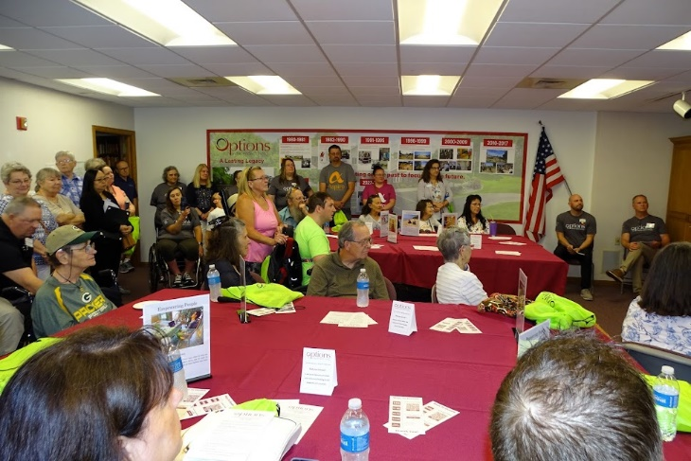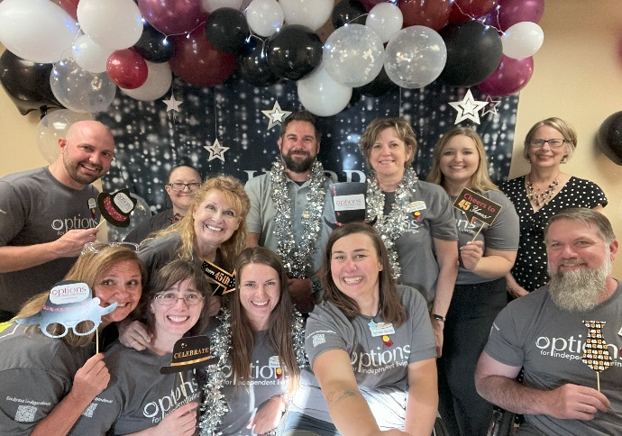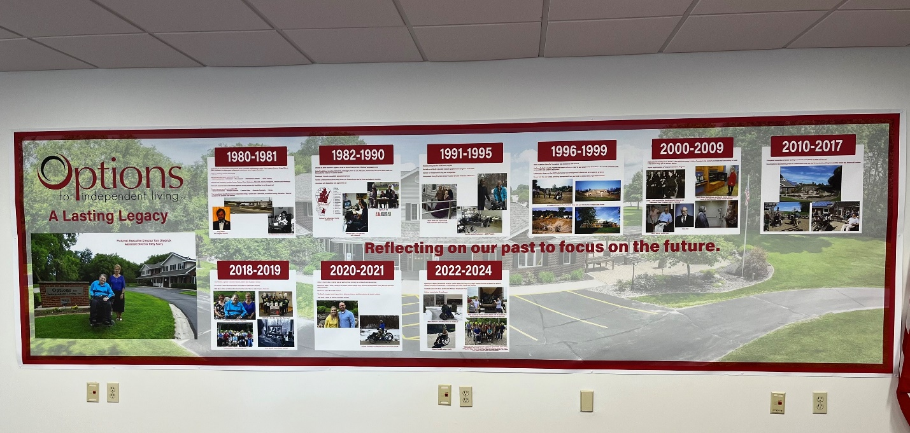

# One July 24, 2024, Options hosted the Disability Caravan for Freedom and Justice in celebration of the Americans with Disabilities Act 33rd Anniversary. Over 70 people were in attendance to enjoy the Caravan crew, Marilee Adamski -Smith and her husband Joseph. The program included Green Bay Mayor Eric Genrich welcoming everyone to Options and the Caravan to Green Bay. Marilee Adamski-Smith, Representative for the Caravan, spoke about the positive effects the ADA has had on the lives of people with disabilities, along with garnering support for the Latonya Reeves Freedom Act, which is a bill focused on keeping people living in the community instead of nursing homes. A couple of Options staff spoke along with a Representative from the Green Bay Area League of Women’s Voters, emphasizing the importance of people with disabilities getting out and voting.

# Pictured is the ADA Van wrapped in Red, white, and blue flag colors with the stars and stripes of the flag. The word on tha van are "Caravan for Disability Freedom and Justice ". There is also a vintage picture of disability Advocates from years past and LaTonya Reeves Act Photo. the Van is pulling a trailer which is also wrapped in Red, white, and blue and words the same as the Van. Tere are alos a couple of brown metal chairs in the picture front left. It was a windy but warm afternoon with no rain. A good day for all! Pictured below is the Caravan with trailer and the Caravan with all in attendance.

# On Thursday, August 22, Options held a Wheelchair Wash and Safety check. Sponsored by the Knights of Columbus Council 617 and NuMotion from Appleton. About 25 people attended and 9 chairs were washed and cleaned. Options adaptive recreation equipment was viewed and tried out. Plenty of hotdogs were eaten and a good time was had by all!

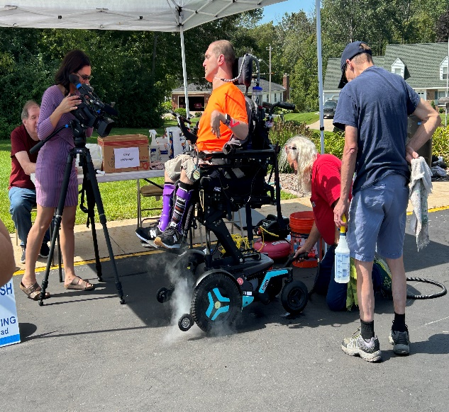 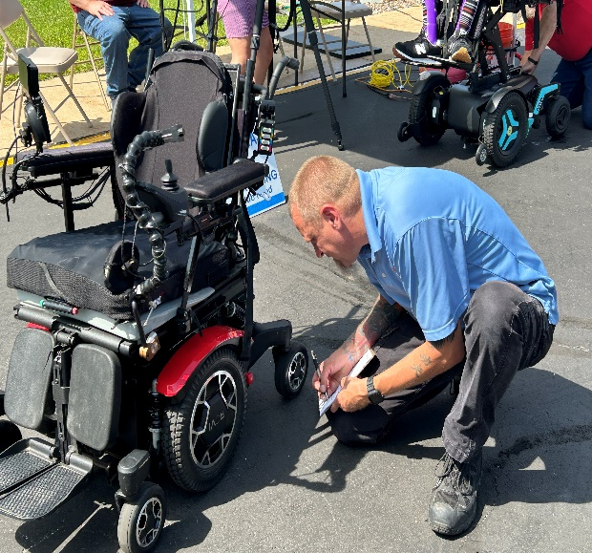

# **2024 Elections - Please Remember to Vote! Your Voice Counts!**

# 2024 will be an important voting year for everyone. We will be voting for President, and in US House and Senate seats, and State Senate and Assembly seats. Please make sure you are registered to vote and be aware of where you can vote in your area. Below is information on upcoming elections in WI and how to make sure you are registered or how to register, find your polling place, how and when to apply for absentee voting, etc. Remember, voting is a right! Please exercise your right to vote!

# **Tuesday, November 5, 2024**: Fall general election

# To check if you’re registered to vote, register to vote, request an absentee ballot, find out what will be on your ballot, and more, visit: [www.myvote.wi.gov](http://www.myvote.wi.gov). If you need help with registering or your polling place is inaccessible, please contact Sandy Popp at Options for assistance, 920-393-1043 or [sandyp@optionsil.org](mailto:sandyp@optionsil.org),.

# In Wisconsin, you can register to vote 4 different ways:

# **Online** at[**myvote.wi.gov/**](https://myvote.wi.gov/)This requires a photo ID and can be done up to 20 days before the election.

# **By Mail** This can be done up to 20 days before Election Day. Mail in the completed registration form to your municipal clerk.

# **In-person** at the municipal clerk’s office through the Friday before the election. You must provide proof of residence.

# **On Election Day** at your polling place. You must provide proof of residence and a photo ID.

# To find out about acceptable forms of Proof of Residence visit:

<https://myvote.wi.gov/en-us/ProofofResidence>

# To find out about acceptable forms of Photo ID visit: <http://bringit.wi.gov>​

# Have Questions? Any of the resources below can help!

# Contact your Municipal Clerk: <https://myvote.wi.gov/en-us/My-Municipal-Clerk>

# Disability Rights Wisconsin Voter Hotline: 1-844-347-8683 / 1-844-DIS-VOTE [info@disabilityvote.org](mailto:info@disabilityvote.org)

# Wisconsin Elections Commission: <https://elections.wi.gov/> or call 1-866-VOTE-WIS (868-3947)

# Department of Motor Vehicles (DMV) Voter ID Hotline: 844-588-1069

# WI Disability Vote Coalition: disabilityvote.org/

# **Want to Get Involved in Legislative Advocacy? It’s easy, join Act Now!**

# Do you want your voice to be heard, but feel your voice alone would not be enough? Join *Options’* legislative advocacy network, **Act Now!** Individuals in the network receive legislative alerts and updates on issues impacting people with disabilities. When an alert or update is received, everyone on the network is encouraged to pursue the issue by contacting their area legislators, therefore combining your voice with many! Act Now alerts can be delivered either through email or US Postal Mail.

# Contacting your legislators about issues that may affect you, or someone you know, is important. Your legislators want to hear firsthand how legislation being considered can impact your life positively or negatively. It helps in their decision making. Joining **Act Now** will assist you in those efforts. This network will educate you on the issues and help you to advocate more effectively. The more people in the network, the greater the impact.

# If you are interested in joining Act Now, contact Sandy Popp at *Options* (920) 393-1043 or toll-free at (888) 465-1515, ext.179, or sandyp@optionsil.org.

# **Options Welcome Two New Staff**

# **Dave Wittlinger** - I was born the youngest of 7 children into a wonderful and loving family in August of 1978. I have always had a passion for the outdoors since I was able to walk around the woods and rivers near our family cabin in northern Marinette County. I especially enjoyed fishing, hunting, camping, cross-country skiing, golfing, and any natural adventures I could find as well. I had been a carpenter until I decided to follow my love for the outdoors which led to being a college graduate from the University of Green Bay Wisconsin with a bachelor’s degree in environmental science and furthermore a position as a wildlife technician, facilities and lands technician for the WI Department of Natural Resources. Life then led me to a carpenter position for the City of Green Bay Dave is pictured wearing a black hoodie, green pants and green cap sitting in his wheelchair on a pier holding a large northern pike. Dave has a salt and pepper colored beard. A friend is pictured with Dave. The friend is wearing his hat on backwards, a multi- colored jacket and tan cargo shorts holding a wire fishing net. parks department. During November of 2017, while hunting, I suffered a fall from a tree which has left me a T11 complete paraplegic.

# Fortunately, life also led me to the marriage of my wife and my current position as an Independent Living Coordinator for Options for Independent Living since November of 2023. Here at Options, I find myself grateful every week to be working toward new passions in creating connections with the public, to do what I can to help people see that they can get out and enjoy things that they may have thought they would never be able to do, or to do again. Welcome Dave!

# **Hannah Jakubek** - I was born and raised in the Fox Valley, graduating from Appleton East in 2011 with honors. I have an older brother, Dylan, who currently lives in Arizona. My parents raised us in a loving, understanding and open-minded way that encouraged us to explore the world and our talents as we aged and changed. As a family throughout grade school, we ventured on many cross-country road trips, camping weekends, amusement park days, and enjoyed much quality time with extended family and friends – all activities that I continue to pursue vigorously as an adult.

# I graduated Magna Cum Laude from Carroll University, Waukesha, WI in 2015 with a Bachelor of Science in Photography and a minor in Business Entrepreneurship. After college graduation, I moved to the tri-state area of WV, OH & KY for several years (2015-2020) for a change of scenery and returned home right at the start of 2020.

# Hannah is pictured wearing a red jacket. She has long brown hair and is smiling at the camera. As an avid traveler, I am lucky to have embarked on some phenomenal adventures spanning 3 continents, 7 countries and more than half or the U.S. states. Locally, you can find me “at the barn” with the horse I adopted in 2010, Cody the TB/Mustang, or with my shelter mutt, Rylee, who joins me on all kinds of fun including kayaking, snowboarding, photoshoots, gardening, weekends up north at the cabin, and many of my travels!

# Having been hired at the start of the 2024 new year as an Independent Living Coordinator at Options, I am excited for the opportunity to fulfil and develop our newly established position: Youth Transition Specialist! I have always had a passion for working with people from all walks of life and I feel like, after many years of successfully managing stores and teams in the corporate retail sector before joining this team, Options is an organization that really facilitates a space to empower its consumers, community and employees to achieve their goals. Welcome Hannah!

# **Consumer Advocacy Success Story**

# Options staff worked with a consumer in Door County who lived in a housing unit that had hallway fire alarms, but she could not hear them when sleeping due to her hearing loss. The consumer had requested a fire alarm system connected to the hallway alarm be placed in her apartment as an accommodation. She was told they would not and did not have to accommodate her in that way. Consumer contacted Options to ask about an alarm system for her unit that would pick up the hallway alarm sound and alert her while sleeping. One of Options Assistive Technology Specialists met with the consumer and put a system next to her bed that would include a strobe and bed shaker. A sensor unit would be placed outside her apartment above her apartment door to pick up the hallway alarm sound. When the building manager found out about the sensor, consumer was asked to take it down making the alert system non-applicable for her needs.

# Options Assistant Director was asked to intervene and worked with consumer to file a complaint through Wisconsin Equal Rights Division (ERD). Her complaint to ERD was that the apartment complex would not accommodate her needs as a person with a hearing loss and place an alert system in her apartment to alert her to a building fire. Over a year later the consumer was told ERD had decided in her favor and the apartment complex was told to place an alert system in her apartment as an accommodation for consumer to reside safely in her apartment. Although it took time, the consumer is now living in an apartment that is safe for her needs.

# **Options is Partnering for Parks!**

# Options for Independent Living and Midstate Independent Living Choices are working in partnership through a grant provided by the Wisconsin Department of Human Services “Healthy Aging and Living with Disabilities Through Livable Communities” grant to enhance accessibility within our community’s park systems. Through this collaborative project we aim to address the critical need for accessible public parks within our collective service area communities consisting of 28 counties including 7 tribal nations. By using our expertise, resources, and community partnerships, we seek to make significant strides in enhancing accessibility and inclusivity in outdoor recreational spaces. Together, we are working to perform Americans with Disabilities Act assessments for readily achievable barrier removal at park facilities, provide recommendations for improvements, and offer ongoing technical assistance to ensure that individuals with disabilities can fully participate in park activities and enjoy the benefits of outdoor recreation.

# We are confident that this project will have a beneficial impact on our communities, fostering greater accessibility, inclusion, and enjoyment for individuals of all abilities. Parks play a vital role in promoting health, recreation, and community engagement but many individuals with disabilities face barriers that limit their ability to fully participate in park activities. We are grateful for the opportunity to work toward using this grant to advance our mission of empowering individuals with disabilities to lead fulfilling and independent lives. Our aim is to address a critical need within our community for improving the accessibility of public parks for individuals with disabilities.

# So far, these assessments have been eye opening to the need that exists and the slow progress that is taking place toward the changes that can be of benefit to all park users. Some examples of beneficial change and necessary updating include: website accessibility, location and number of accessible parking spaces, more inclusive and accessible restrooms, accessible routes to all park features including playgrounds, beaches, pools, boat launches, fishing piers, sports fields, detailed trail descriptions of length, surface conditions, elevation changes, tactile mapping, braille signage, and the inclusion of sensory areas provided for people with audible or visual sensitivities.

# Progress is happening, but we hope our assessments and reporting will create a better understanding of how our community park systems can remove barriers to foster inclusivity in the parks to promote and provide for the well-being of individuals with disabilities.

# **Modification Navigator (NAV) Pilot Program Grant –**

# People with disabilities face many physical and environmental barriers daily. In addition, navigating through a benefit system can prove to be overwhelming and equally frustrating. Through a grant awarded to Options for Independent Living, the Modification Navigation Pilot has been able to break down some barriers’ consumers have been presented with. If you are faced with barriers to your independence, are stuck, or are uncertain where to go for assistance, please consider contacting Steve Lafrombois at Options for Independent Living at 888-465-1515. The Modification Navigator Pilot program may be able to assist.

# While the Modification Navigator Pilot is intended to assist those who are participants in IRIS (Include, Respect, I Self-direct) and CLTS (Children’s Long-Term Support) programs, please do not hesitate to call Options as there may be other programs available.

# **Navigator Program Consumer Highlight**

# Joe was referred to Options for Independent Living’s Accessibility Assessment Program by the IRIS Agency to address his need for a mobility device. Joe was having difficulties doing daily tasks because of the chronic pain in his lower extremities when he walked and was in the process of getting a scooter through IRIS. However, there was going to be a delay in receiving the scooter. Through the Modification Navigator (NAV) Pilot Program, Options was able to provide Joe with a scooter for a trial, until he can receive a scooter of his own. This gave Joe the opportunity to test out how a scooter would impact his life.

# Joe is sitting in his power scooter wearing dark shorts and a gray t-shirt. He is holding onto the collar of his service dog, who has a black coat. With the use of the scooter, Joe was able to access his community independently, not needing to plan his schedule around the availability of others. Further, Joe can provide the necessary care to keep his service dog, Oscar, happy and healthy. Being mobile has allowed Joe and Oscar to continue their work as ambassadors for Leader Dogs for the Blind as they start to prepare for their 4th annual benefit. Leader Dogs for the Blind is an organization that provides the tools and training to reintroduce people who are blind or visually impaired to a life of independence, confidence, and companionship, from white cane training to matching individuals with a Leader Dog. The NAV Pilot has not only positively impacted Joe’s life by providing necessary, immediate assistance, but to all the lives of those in his community that he touches through the continued work with Leader Dogs for the Blind.

# **Options Adaptive Adventures Program**

# Did you know Options started an adaptive recreation program named Adaptive Adventures. Options AT staff person, Calvin Richtig, has written grants or accepted donations for numerous pieces of adaptive recreation equipment. Currently Options has a Track chair, a Terrain Hopper, a Firefly attachment for a manual wheelchair to become like an E-bike, an E-Trike, and two tricycles. Calvin also wrote a grant and was able to acquire an adaptive kayak to add to the collection. Kayak clinics will be held this summer. Check with Calvin for dates. Options also has sled hockey sleds and has held clinics throughout the year, which will be coming up soon. If you’d like to learn more about the recreational equipment/programs available and how you or someone you know can experience being outdoors and active once again, please contact Calvin at 920-393-1037 or [calvinr@optionsil.org](mailto:calvinr@optionsil.org).

# **Adaptive Adventures Consumer Highlight:**

# My Dad was diagnosed with PSP, Progressive Supranuclear Palsy. The disease significantly impacts mobility. After the diagnosis, Dad had a few things he wanted to accomplish before the disease robbed him of his life. One of them was to reach and celebrate his 80th birthday. We celebrated that birthday in early July. One of his "gifts" was the use of the outdoor Track Chair from Options to thoroughly enjoy his daughter's farm, where the party was held. The farm was his "happy place" but he hadn't really been able to see the entire property because it is hilly and sandy, which is exceedingly difficult to access with a traditional wheelchair. Over 50 people attended the 80th birthday party and Dad received a squirt gun and his freedom to move about on his own for a day! Dad had a great time and so did the farm animals who followed him around to enjoy the fun!

# **Options LEND Program**

# Options LEND Program is available for people who have temporary or long-term need for durable medical equipment such as walkers, wheelchairs, bath benches, etc. Options takes in donated durable medical equipment that is in good working condition, cleans it up and gives it back to those who need it in our community. We do not take items with electrical cords, power wheelchairs, medical supplies, or hospital beds. Options LEND closet is open **9 to 11:30 am and 12:30 – 3 pm** **Monday through Friday**. For any questions contact Roxanne at Options at 888-465-1515.

# **LEND Program Consumer Highlights:**

# The shower transfer bench helped me a great deal. With foot surgery it was several months with no weight on my foot. I could not have managed without your aid. Thank you!!

# Borrowed a walker. My wife used it after back surgery, it made her very mobile and now can go without. Thank You!!

# The equipment we were given feels very safe for my wife. The knee pads in the middle of the device on the ETAC turner helps her get to a standing position with ease. We use the Etac Turner device daily to stand up and transfer to another chair and stand up and transfer into a vehicle outside also! This device is a thing of beauty when it is used by my wife. Until my wife is completely unable to assist in her transferring, the little turner transfer device is perfect for her at home use! Thank you! And thank you for the LEND program.

# **Tech Closet News** Pictured is the WISTECH logo. It has dark colored large letters spelling out WISTECH, and smaller dark letters underneath spelling out Assistive Technology Program. There is a ribbon of colors underneath the word WISTECH of dark blue green to lighter blue green.

# Options has Assistive Technology (AT) Specialists who can assess an individual with a disability to determine the role assistive technology can play in achieving greater independence. For more information on assistive technology that can help you reach your goal of independence, contact Calvin Richtig, Options AT Specialist, at 920-393-1037 or Ian at 920-393-1053 or toll-free at 888-465-1515 and ask for Calvin or Ian.

# *Assistive technology partially supported by the WisTech, Assistive Technology Program. Telecommunication is partially funded by the Universal Service Fund (USF).*

# **Teltex - GLT Deluxe Captioning Tablet**

# The Teltex GLT deluxe captioning tablet provides an efficient solution to anyone struggling to hear others when they are speaking. This device allows the user to read the captions as they are being spoken aloud in the room. A live transcribe application installed on the tablet helps retain every spoken word in captioned form. The tablet also picks up on both sides of a conversation. This device can be A small computer screen with text on it saying, "this makes life so much easier for those that have a hearing disability." The small screen is on a stand. used offline (in case the user has no internet access). Caption text size is adjustable for easy readability. The tablet also has a simple set up with adjustable stand and power adapter for continuous charging.

# **What is the Telecommunications Equipment Purchase Program (TEPP)?**

# TEPP helps people with disabilities buy equipment they need to use basic telephone services. The TEPP is paid for by the Wisconsin Universal Service Fund (USF) established by the Public Service Commission. Money is collected from Wisconsin telephone service providers to fund USF. TEPP requires that an applicant:

# Be a Wisconsin resident.

# Be a person who is deaf, hard of hearing, speech impaired, or mobility or motion impaired.

# Needs special equipment to use the telephone in the home or when traveling (like a TTY, amplification, visual alert system, etc.).

# There is no age or income limit, but an individual can only get a TEPP voucher once every three years for the same type of disability. For more information on the TEPP program, contact Ian Kaster, Options AT Specialist at 920-393-1053.

# The Telecommunications Equipment Purchase Program (TEPP) is a funding source through the Public Service Commission of Wisconsin that helps people with disabilities buy specialized equipment they need to use with basic telephone services. The allocated funds at the state level help offset the price of equipment, which in turn makes the device more readily available to those who may not have the funds to purchase the device entirely on their own.

# An application would be applied for with an AT specialist, then TEPP would issue you a voucher (physical copy) a few weeks after filling out that said application with us. The voucher can then be applied to an item of your choice. The items eligible for purchase with this TEPP voucher are subject to change and we will help you understand what eligible items are allowed to use your voucher for and what items are not able to be purchased with your voucher.

# People often have trouble understanding how to navigate the state program to determine exactly how to use the TEPP program. We will help you make an educated choice on what voucher best fits your needs. We will also help direct you toward the equipment that would benefit you the most by demonstrating how equipment works and possibly loaning items to you. This would allow you to trial a device before you make a purchase. The final installation of a new device and pairing of equipment that is received can sometimes become an obstacle, so we will also help you with the learning and adaptation of that new device in your home.

# Many lives have changed due to the help of our staff at Options for Independent Living. The following is just one of those testimonies that helped empower people to live independent and productive lives:

# I am very thankful for all your help with ordering my alert system. And thank you for helping me navigate the use of my TEPP voucher. You were also a great help with the setup of my equipment when it arrived. Your great!

# **BENEFITS BUZZ – Medicaid Purchase Plan (MAPP) Update**

# If you are a MAPP recipient, starting in August 2024 you need to pay a monthly premium for MAPP if your total gross income is more than $1,255.00 per month.  That is 100% of the current Federal Poverty Level.  The amount of your MAPP premium is based on your monthly income.  If you have out-of-pocket medical or remedial costs, it may lower your MAPP premium.  You can let your Consortium know if you have those costs.  You will receive a notice telling you the amount of your MAPP premium and how you can pay it.  You should pay your MAPP premium by the 10th of each month.  You can find more information online at <https://www.dhs.wisconsin.gov/medicaid/medicaid-purchase-plan.htm>.

# **Benefits - Consumer Highlights**

# Karin Zuleger, *Options*’ Work Incentive Benefits Specialist, assisted a consumer who just had his first Medicaid renewal since the COVID pandemic started.  He was told that he would now have to meet a deductible of more than $8,000.00 before he could qualify for Medicaid.  Based on the information he provided, Karin estimated that the consumer could qualify for the Medicaid Purchase Plan (MAPP).  She contacted the Consortium and advocated on his behalf.  The Consortium reviewed his case and decided he qualified for Medicaid through MAPP and did not have to meet the deductible.

# Options Work Incentive Benefits Specialist was working with a consumer who was on IRIS and then applied for the Medicaid Purchase Plan (MAPP). Due to a mix-up when the consumer applied for MAPP, the consumer’s IRIS eligibility was ending. Options Benefits Specialist discovered the mix-up and helped to correct it. Consumer now is on MAPP and retains her much needed IRIS services

# **Options has HOME funds for Home Accessibility, Rehabilitation, or Repair**

# The HOME Loan Program provides deferred payment / no interest second mortgage loans to make homes accessible or make home repairs. The loans are focused on providing resources to households that include someone who has a disability or is older and is at low-to-moderate income status. Options receives funds for the HOME from the US Dept. of Housing and Urban Development through the State of Wisconsin Dept. of Administration, Division of Housing to administer the HOME Investment Partnership Program (HOME Loan Program.)

# The loan must be paid back when the property is sold, transferred, or ceases to be the borrower's principal place of residence. Types of projects include (but not limited to) ramp construction, bathroom, kitchen, and bedroom modifications, along with general housing rehabilitation and repairs.

# The counties served by this program include Brown (outside Green Bay City limits), Calumet, Door, Fond du Lac, Green Lake, Kewaunee, Manitowoc, Marinette, Marquette, Menominee, Oconto, Outagamie, Shawano, Sheboygan, Waupaca, Waushara, and Winnebago counties. Applicants must meet the eligibility requirements to be considered for a loan. For more information contact Steve LaFrombois at [stevel@optionsil.org](mailto:stevel@optionsil.org), 920-393-1044, or toll-free at 1-888-465-1515, ext. 122.

# **Options’ Personal Assistance Program for Those on Medicaid**

# Options’ Personal Assistance Services (PAS) Program empowers people & families with disabilities to manage their in-home cares, including the selection of their Care Worker so that they can maintain a strong relationship with them and remain involved in the daily life of their family.

# Certified to provide services through Medicaid and to sub-contract services through IRIS, Options’ PAS program has been helping adults in need of in-home care for years.

# **Benefits of Using Options for Personal Care Services:**

# Options is not a Staffing Agency. Individuals can have family or friends to provide the care.

# Options can provide training for new Care Workers.

# A Case Manager will provide supervision of the Care Worker and coordinate service needs.

# Benefits include Health, Dental & Vision insurance as well as Retirement Savings Accounts for full-time Care Workers (30+ hrs./week.)

**For More Information contact: Karen Phillips** – ***PAS Program Director***. [karenp@optionsil.org](mailto:karenp@optionsil.org). 920-393-1036. Toll Free: 888-465-1515 ext. 182

**Jennifer Lardinois – *CLTS Case Manager / Care Coordinator***. [jenniferL@optionsil.org](mailto:jenniferL@optionsil.org). 920-393-1032. Toll Free: 888-465-1515 ext. 181

# **Wisconsin WisLoan Program**

# WisLoan is a statewide alternative loan program helping Wisconsin residents with a disability purchase assistive technology that assists them in living more independently and productively. Any Wisconsin resident with a disability over the age of 18 in need of assistive technology or home modifications is eligible to apply for a loan. Some examples of assistive technology include wheelchairs, hearing aids, Closed Circuit Televisions (CCTV’s), and vehicles with modifications, or the modifications necessary to make a vehicle accessible. For more information or to apply for WisLoan call Options at 920-490-0500 or toll-free at 1-888-465-1515.

# WisLoan is a federally funded project of the National Institute for Disability and Rehabilitation, and a cooperative service of the Wisconsin Dept. of Health Services, IndependenceFirst, and BMO Harris Bank.

# **Wisconsin Telework Loan Program**

# The Wisconsin Telework program is a statewide, alternative loan program that allows Wisconsin residents with disabilities to purchase computers and other equipment needed to work from home or from other remotes sites, e.g., work on the road or at a telework center. Loan funds can be used to purchase equipment, training to use equipment, extended warranties, and cost of maintenance and repairs. For more information, contact the staff at Options for Independent Living on 920-490-0500 or toll-free at 1-888-465-1515.

# This program is made possible through a grant from Rehabilitative Services Administration (RSA) and authorized by Section (303)b of the Rehabilitation Act of 1973, as amended, and implemented by subsequent program regulation 34 C F R Part 373. The Department of Workforce Development-Division of Rehabilitation received the grant and provides programmatic and fiscal oversight. IndependenceFirst, a community based, and consumer-controlled independent living center based in Milwaukee, administers the program in partnership with BMO Harris Bank and Wisconsin Independent Living Centers.

# **MISSION STATEMENT:** Optionsfor Independent Living, serving people with disabilities in 17 counties of Northeast Wisconsin, is the pre-eminent non-profit organization of choice to empower people with disabilities. Options provides opportunities, through advocacy and education, for individuals with all disabilities and ages, to actively access their communities, maximize their independence, and connect with the resources and funding available to them.

# Visit us on our website or Faceboo*k*!Optionswebsite is: [www.optionsil.com](http://www.optionsil.com) Facebook is: <https://www.facebook.com/optionsil.greenbay/>

# **Staff List**

# GREEN BAY OFFICE 555 Country Club Road, Green Bay, WI 54307

# Front Desk 920-490-0500 Toll Free 1-888-465-1515 Fax 920-490-0700

# Executive Director Josh Theis 920-393-1045 [josht@optionsil.org](mailto:josht@optionsil.org)

# Assistant Director Sandy Popp 920-393-1043 [sandyp@optionsil.org](mailto:sandyp@optionsil.org)

# Accountant Peggy Mass 920-490-8270 [peggym@optionsil.org](mailto:peggym@optionsil.org)

# Housing Program Manager Steve LaFrombois 920-393-1044 [stevel@optionsil.org](mailto:stevel@optionsil.org)

# Accessibility Assessment Specialist Sarah Dunks 920-393-1034 [sarahd@optionsil.org](mailto:sarahd@optionsil.org)

# Accessibility Assessment Specialist Marie Smith 920-393-1046 [maries@optionsil.org](mailto:maries@optionsil.org)

# Accessibility Assessment Specialist Becky Bookter 920-393-1048 [beckyb@optionsil.org](mailto:beckyb@optionsil.org)

# Assistive Technology Specialist Calvin Richtig 920-393-1037 [calvinr@optionsil.org](mailto:calvinr@optionsil.org)

# Assistive Technology Specialist Ian Kaster 920-393-1053 [iank@optionsil.org](mailto:iank@optionsil.org)

# Work Incentives Benefits Specialist Karin Zuleger 920-393-1039 [karinz@optionsil.org](mailto:karinz@optionsil.org)

# Independent Living Coordinator Supervisor/Memory Loss Technology Specialist Stacie Scheibe 920-393-1050 [stacies@optionsil.org](mailto:stacies@optionsil.org)

# Independent Living Coordinator Dave Wittlinger 920-393-1055 [davew@optionsil.org](mailto:davew@optionsil.org)

Youth Transition Coordinator Hannah Jakubek 920-609-7080 [hannahj@optionsil.org](mailto:hannahj@optionsil.org)

# Advocacy Coordinator Autumn Nordall 920-393-1035 [autumnn@optionsil.org](mailto:autumnn@optionsil.org)

# Supportive Home Care Program Director/Personal Assistant Services Karen Phillips, MSN, RN 920-764-2446 karenp@optionsil.org

# Personal Care Program Care Coordinator Jennifer Lardinois 920-393-1032 [jenniferl@optionsil.org](mailto:jenniferl@optionsil.org)

# Billing Specialist Missie Olm 920-393-1048 [missieo@optionsil.org](mailto:missieo@optionsil.org)

# Secretary Barb Guyes 920-490-0500 [barbg@optionsil.org](mailto:barbg@optionsil.org)

# Office Assistant/LEND Lead Roxanne Kiefert 920-393-1054 [roxannek@optionsil.org](mailto:roxannek@optionsil.org)

# Certified Peer Specialist Dave Zanon 920-903-0391 [davezoptionsil.org](mailto:davez@optionsil.org)

# **OPTIONS BOARD OF DIRECTORS**

# Scott Anderson, President Connie Greenawald, Vice President Jacob Ruatti, Treasurer Lynn Smits, Secretary

# **MEMBERS**

# Steve Boney Christy Coenen Keith Pamperin Sherrill Revolinski Eric Stream